Missionary Fund Calculations

Making calculations for the missionary fund is based on a whole bunch of assumptions about what will happen in the future (who goes on missions, how long they stay, who pays, who doesn’t). I accounted for this uncertainty by making probabilistic assignments to the likelihood of each event and then simulating thousands of scenarios to explore the range of possibilities.

For the initial calculation, I used the following probabilities and figures, but I made them all easily updatable, so if you have a strongly different belief we can edit it and easily rerun the numbers:

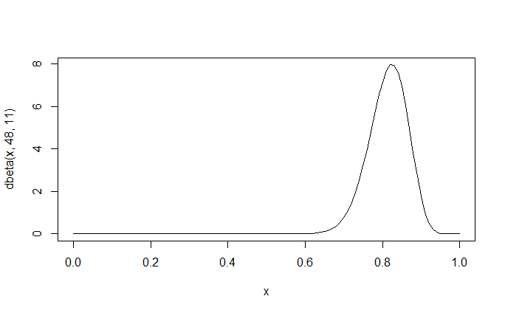1. Probability that a boy in the family goes—for each simulation I drew this probability randomly from a distribution that looked like this:

The mean of that is 81% and all boys in the family are assumed to have equal chances of going.

2. Similarly the girls’ distribution looked like this:

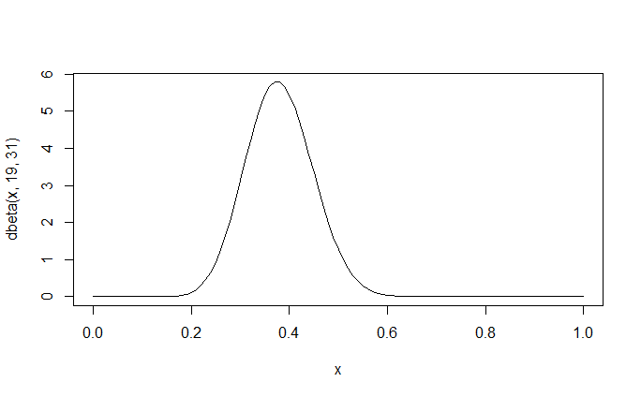(mean of 38%)

3. Probability of what age a boy would go: 18—90%, 19—6%, 20—2%, 21—1%, 22—1%

4. Probability of what age a girl would go: 19—90%, 20—4%, 3%, 2%, 0.5%, 0.3%, 0.2%

5. Probability of when they would leave—the three summer months were set to be equal to the other 9 (half the missionaries would go in the summer).

6. Boys had an 80% of serving two years. 12% chance of coming home in first 6 months, 8% the rest.

7. Girls 76.75% of serving 18, 15% in first 6, rest in the rest.

8. Adults were assumed to pay $30/month

9. Probability that adult pays on any given month 98%

10. Grandkids who participated assumed to pay $5/month

11. Probability grandkid pays any given month 90%

12. Probabilities that grandkids would choose to participate was also assigned randomly from a distribution. The RM distribution was centered at 85% and the non-RM distribution at 40%. Since I had no experience to go off this assumption is highly questionable!

13. I attempted to model the “Gio” effect, the chance that are family could grow from adoptions, remarriages, etc. I added new kids at random ages in the family with probabilities: 0—92%, 1—4%, 2-5—1% each.

14. I attempted to model the loss of one of the adult payers (e.g. through death). I assigned it a 50% chance of happening, and if it happened it was equally likely to be any year.

**The Results**

The initial results look really good for the long-term viability of the missionary fund. For all the following graphs, I plot two scenarios: one with the parents being the only contributors to the missionary fund, and one in which the grandkids are invited to participate starting August 2017.

**Long-Term Prosperity**

In the long-term, the financial footing of the missionary fund is good. 18 years out (that is as far as I projected because modeling great-grandkids births is an entire other project) the amount in the bank account is likely to be $20,000 to $45,000 without interest (no attempt was made to model interest accrual) if the current rate of $30/month was kept.

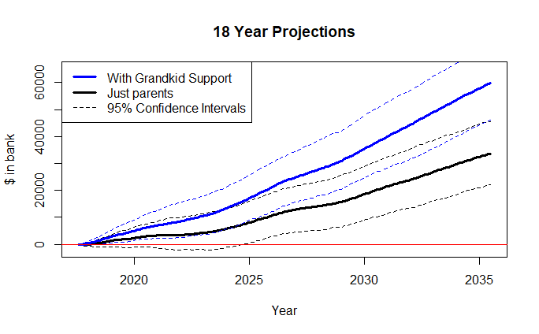

**Short-term Shortfalls**

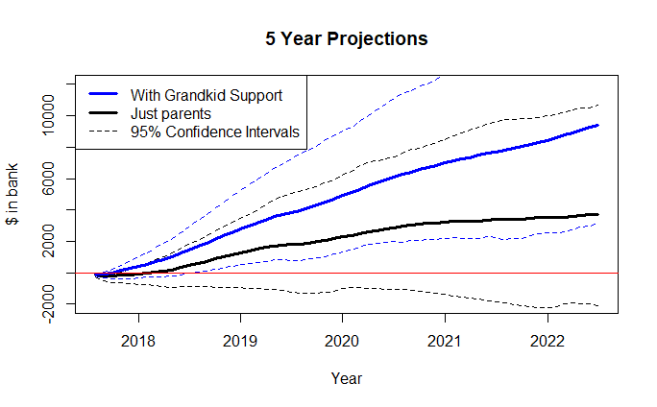

The short-term outlook is quite likely negative for at least twelve months with only parent-support, and there is a lot of downside that could extend that into the future. The biggest commonality driving the “negative” scenarios are the number of missionaries (especially girls) choosing to serve. The following is a table of the probability of being in the red at the start of each year.

|  |  |  |  |  |  |  |  |
| --- | --- | --- | --- | --- | --- | --- | --- |
| Year | 2017 | 2018 | 2019 | 2020 | 2021 | 2022 | 2023 |
| Parent Support Only | 63.9% | 15.9% | 11.2% | 8.2% | 22.7% | 11.1% | 7% |
| Grandkid Support | 16.6% | 0.8% | 0.4% | 0.2% | 0.3% | 0.1% | 0% |

**One Possible Solution**

Getting the grandkids involved is a short-term necessity in confidently avoiding debt, but the fund is more than self-sustaining in the long run. One proposal would be to invite all grandkids to start contributing $5/month and ask the parents to continue contributing $30/month until the start of 2020. After that we could adjust the parents’ payment to $20/month. Under that scenario our future would look like:

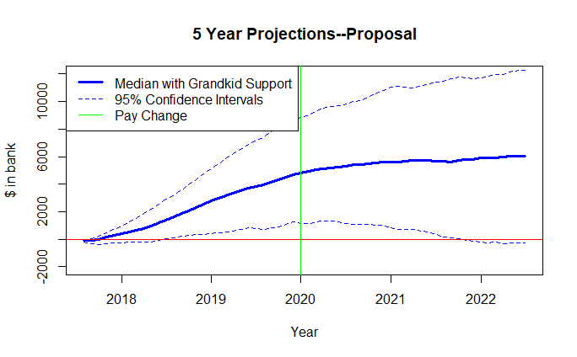

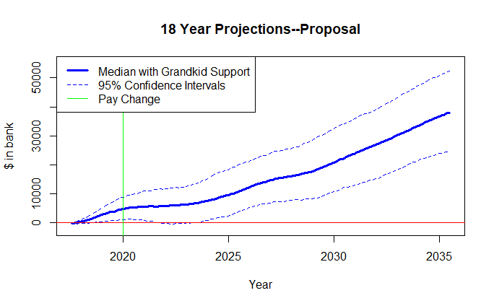

An obvious benefit of this is that as 2020 gets closer we can reanalyze where we sit, and if we are headed towards our “worst-case scenario” we can maintain the current rates until we feel confident. In addition, what is exciting to me under this scenario is that it will start to build a sum that can ensure it is available for the next generation. By the end of the 18 years we will have between $25,000 and $50,000, plus the accumulated interest to begin funding the next generation of missionaries.